**E-commerce Microservices Setup Guide**

Step -1 : Update system package

Step 2 : Install java21 the check the version

Step-3: Install Gradle 8.5

Step 4: Steup the gradle environment.

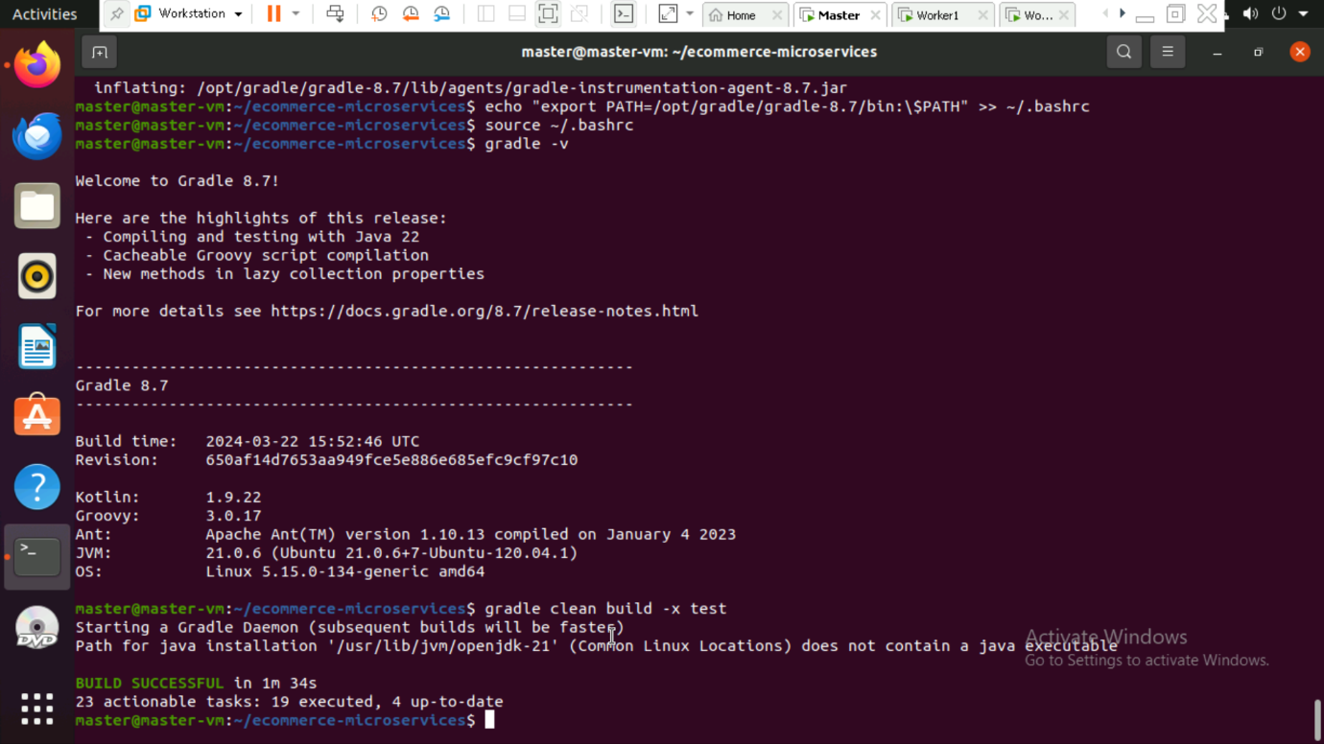

Step 5: Install Docker compose

Step 6: Setting up the project

Step 7 : Build the microservices and test



Step 9: verify the container using “docker ps” and check service logs using “docker logs order-service”.

Step 10: Stop and restart all the service.

Step 11: Verify PostgreSQL in Docker.

Step 12: Push the built images to dockerhub using “docker-compose build” and “docker -compose push”.

Step 13: Kubernetes Setup

**Output**

